New Student Enrollment Instructions
If you are a new Parent/Guardian to the area, welcome! This guide will walk you through the online registration process.
Online registration is set up to allow you to register your student for their home school. If you would like to register for another school, contact the office of that school for assistance.
Follow the steps below to enroll your student.
- Click the Login link on the ParentVUE page or open the mobile application.
ParentVUE Login

- Select More Options.
- Select Create a New Account
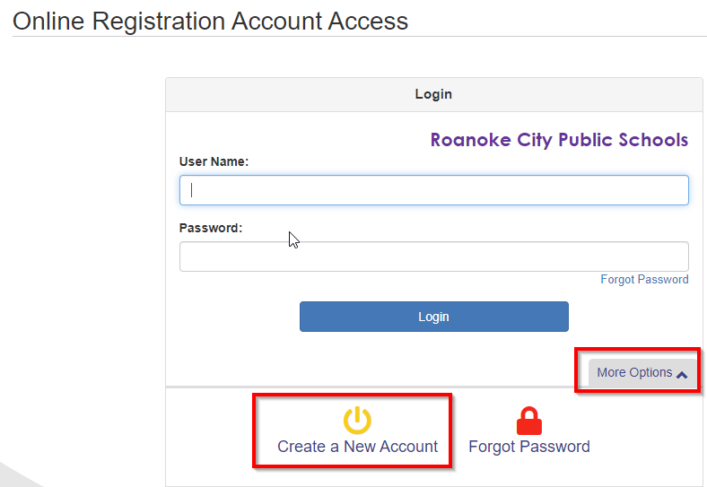
- Answer the three (3) questions on the screen.
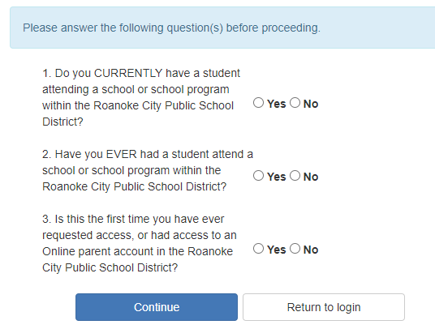
- Read through the Privacy Statement. If you agree to the terms, click “Accept.” You must agree to the privacy statement to use online registration. If you do not agree, click “Return to Login.”
Note: If you have one or more students already enrolled in the district, you need to exit this registration and log into your existing ParentVUE account.
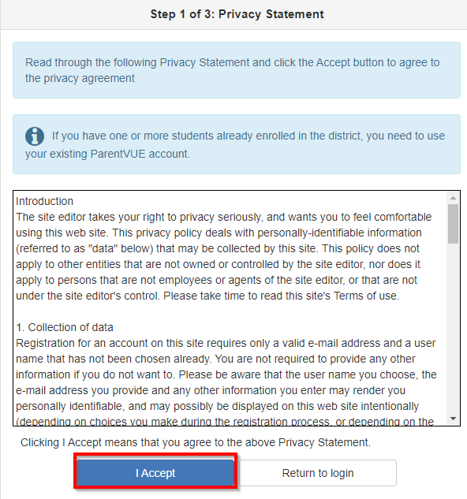
- Create Your Account by completing all the fields. Once you have entered all the information, click “Continue to Step 3.”
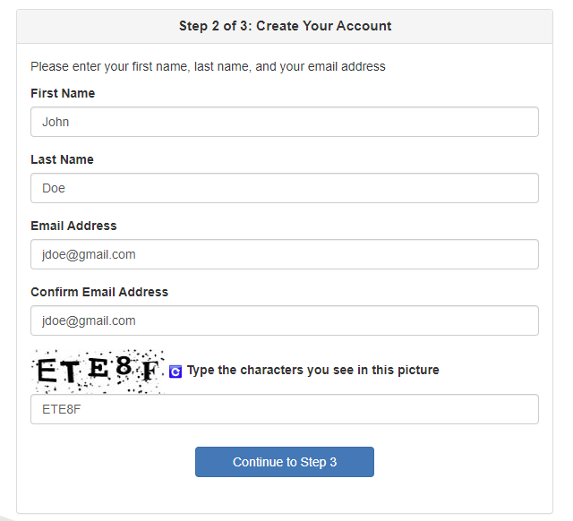

- Open the email sent by the system and click on the ‘here’ link to complete the account create process.
Hi John,
Welcome to the ParentVUE online registration portal. Click here to complete the account creation process and begin online registration.

- By default, your User ID is your email address. Enter a password of at least six characters and confirm it. Then click on Save and Continue.

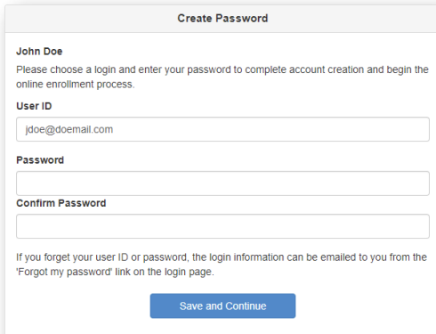

- At this point, you should be signed into online registration.
New Student Enrollment
There may be more than one registration line to choose from for online enrollment. Select the New Student Enrollment for the correct year. Click Begin New Enrollment button.
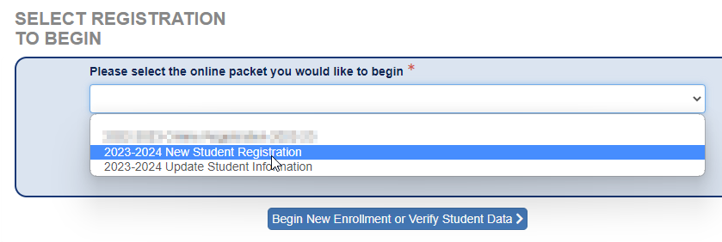

- NOTE: If at any point you are unable to complete the enrollment process in one sitting, you may click the “Log Out” button in the upper right-hand corner of the screen at any time. When you log back in, you will be prompted to resume the registration process. Click “Resume Registration” to finish the enrollment.
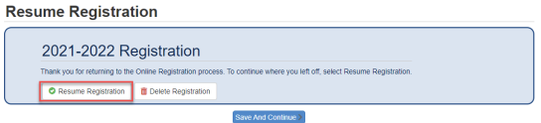
- The Welcome Page will give you an overview of some of the required documentation that you will need during the registration process. These documents will need to be hand delivered to the school office.
Please have the following information available to assist with online enrollment:
- Student’s Birth Certificate (or Affidavit)
- Emergency contact phone number(s)
- Previous school year information
The following forms will need to be provided or completed in person:
- RCPS Student Health Form
- Student Code of Conduct Booklet
- Proof of Residency
- Birth Certificate
- Social Security Card
- Documentation of Custody
- When you are ready, click “Continue” at the bottom of the page.
- Read the instructions at the top of each page to guide you through the process.
- At the end of the process, click ‘Review’ and read over all registration data.

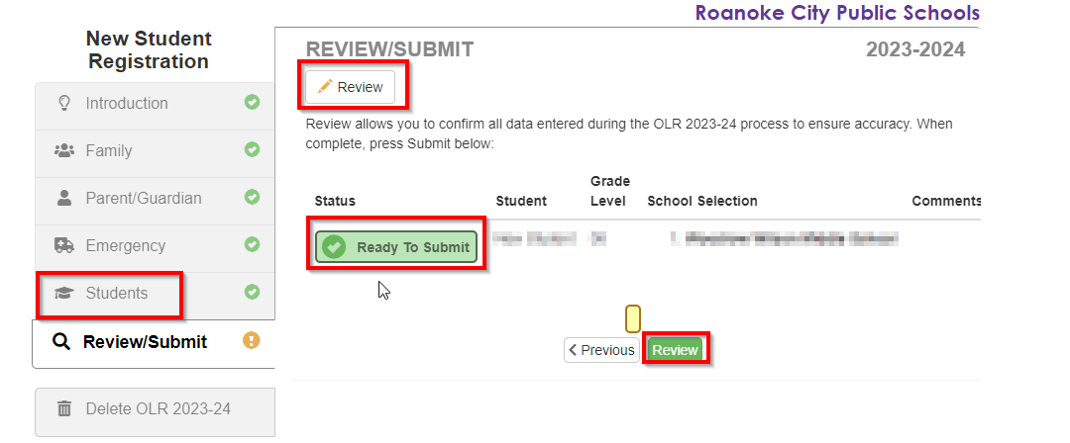

- Scroll to the bottom of the Review screen and check the box to verify all data is correct.
Click Submit.

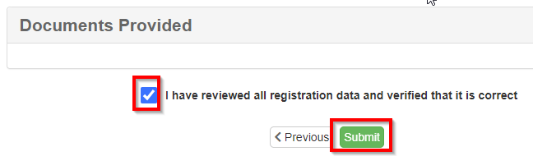
- Once your registration is submitted, you should receive an email confirming that the registration was submitted.
- Contact your student’s school to schedule your in-person registration appointment. Your student is not enrolled until this appointment is completed.
- You can check on the status of your registrations by looking at the Online Registration Status page.

